Chapter 12-[Recursive Definition](https://mfleck.cs.illinois.edu/building-blocks/version-1.3/recursive-definition.pdf)

Thursday, January 5, 2023

1:12 AM

***Recursive Definitions:***

Similar to recursive functions in programming.

Has 2 parts:

A Base Case(s)

A Recursive Formula

Fibonacci Numbers Definition Example:

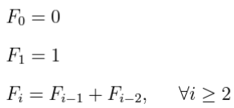

Most recursive numerical formulas have a ***closed form***, or an equivalent expression that doesn't involve recursion.

*(basically big brain ways to summarize a recursive function into a math formula)*

***Unrolling:***

A Technique used to find the closed form.

*(unrolls the recursive part, substituting in previous values)*

Example:

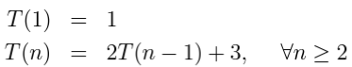

Unroll:

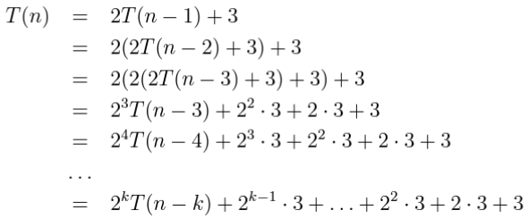

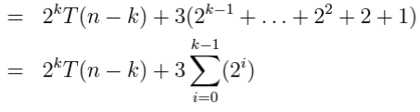

But notice that there's still a k hanging in there (because we don't know for how long the function will go)

That's when we need to use the base case

From the definition, we know that n=1 is the base case

And so from the unrolled formula we know to substitute 1 into n-k. (and k = n-1)

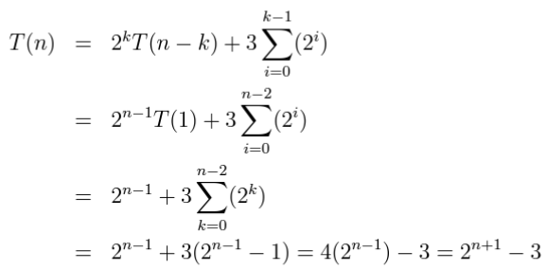

Another Example:

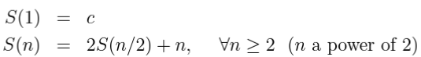

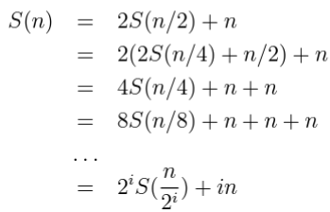



***Hypercubes:***

Defined Recursively as follows:

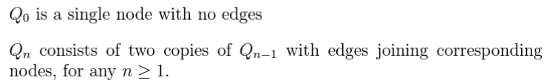

Diagrams:

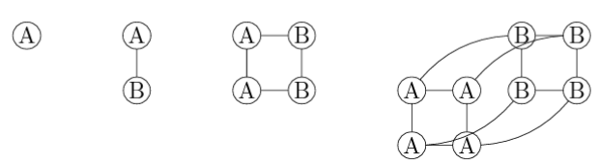

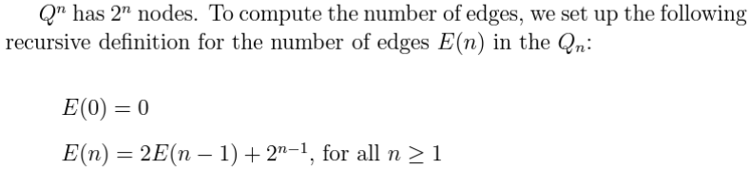

***Proofs with recursive definitions:***

Claims involving recursive definitions often require proofs using a strong inductive hypothesis.

*(Since it is often necessary to substitute in/refer to previous values in these proofs)*

Example:

f(n) is defined to be:

